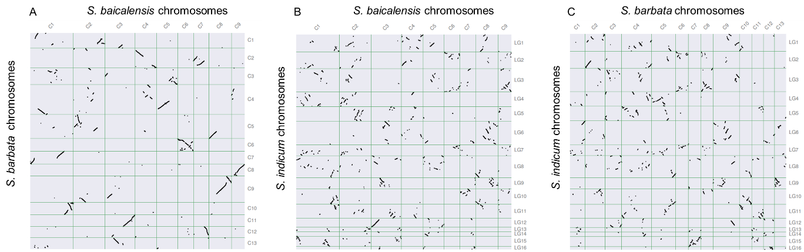

Supplementary Fig. S3. Genome synteny analysis between *S. baicalensis* and *S. barbata* (A), *S. baicalensis* and sesame (B), *S. barbata* and sesame (C), respectively, using MCScanX.